SCHOOL REPORT: 2019-20

[Knowledge is power. Information is liberating. Education is the premise of progress, in every society, in every family.](https://www.brainyquote.com/quotes/kofi_annan_389917) Education is not the learning of facts but the training of the mind to think. The Chinese proverb says, “If you are planning for a year, sow rice; if you are planning for a decade, plant trees; if you are planning for a lifetime, educate people.”

We take this opportunity to thank the Almighty for His abundant blessings. Real education teaches us to live life to the fullest. It cannot be measured in any tangible way.

I am glad to present before you a concise report of St. Paul’s English Medium School for the academic year 2019 - 2020.

The School re-opened for the academic year 2019 - 2020 on 17th June 2019. We began the year with the blessings of the Almighty. St. Paul’s English School provides an ample of scope for the children under the guidance of our director Rev. Dr. Valerian Fernandes.

Our School is situated in MIDC Area, Paithan and blossoming with flying colours. Bangar Rushikesh Prabhakar stood first in school by scoring 89% and Takpire Janhavi Madhukar secured 88.40% and stood second in school in SSC Board. We duly appreciate the tremendous co-operation on the part of everyone associated with this Institution who have strived their best to mould our students to work hard and make their dreams and aspiration come true.

We take pride in our students, teachers and the non-teaching staff with whose help the system runs smoothly. We always focus on the holistic development of the students.

We begin our day by seeking God’s blessings through the morning assembly. It consists of reading News, thought for the day and importance of the day. Every Monday Mass PT is being conducted for the physical fitness.

Images are the simplest and the most effective way to make sure that the information gets stored as a long-term memory. As per Dr. Lynell Burmark, an education consultant, our short term memory processes words and can only retain about seven bits of information. Whereas, images are directly processed by our long-term memory, where they get indelibly etched. Visual teaching plays an important role in the lives of students. So teachers utilize smart classes to enrich the students effectively. Students not only learn the lessons taught in the class but also the values for life. School provides Computer Education to update their skills in Computer and technology. Students inculcate the habit of reading and gain knowledge during library period.

**Celebrations and Events:**

* “Yoga is the golden key that unlocks the door to peace, tranquility, and joy.”International Yoga Day was organized by the school on 21st June. Children understood the importance of yoga by performing it.



* Trees are essential for life. They are a crucial factor to our existence not only because they provide us with the materials for tools and shelter, but because they play a vital role in the carbon cycle. Saplings were distributed among the students and teachers to be planted in the school campus marking the importance of the healthy and green environment on 1st July.



* There is nothing more beautiful than someone goes out of their way to make beautiful life of others. Rev. Dr. Valerian Fernandes has also spent his life to make others happy. So, the August 10th every year we celebrate as Founder’s Day. Variety of programmes was organized to show our gratitude to our director Rev. Dr. Valerian Fernandes.

* On the bright morning of 15th August 1947 India achieved freedom from the British rule. This day from then was finally declared as Independence Day and celebrated every year across the country. This day is observed as a national holiday in India commemorating the nation’s independence from the United Kingdom. Independence Day was celebrated by hoisting the National Flag to show our due respect towards the nation. Students delivered speeches in three languages namely English, Hindi and Marathi. Patriotic song was sung by the choir group to instill in us the patriotism.
* September 5th Teachers’ Day is one such event for which students and teachers equally look forward to. Teachers' Day is important for the students as it gives them a chance to understand the efforts put in by their teachers to ensure that they get proper education. Similarly, teachers also look forward to Teachers’ Day celebration as their efforts get recognised and honoured by students and other agencies as well.
* Marathwada Liberation day was celebrated by hoisting the flag on 17th September.
* Christmas is the spirit of giving without the thought of getting and spreading the emotion of love. Jesus Christ is the reason for this season as we commemorate the day as the birthday of Jesus.  Christmas programme was organized on 23rd December with a meaningful skit, dance, and live crib. The inspirational message of Christmas was given by the director.
* 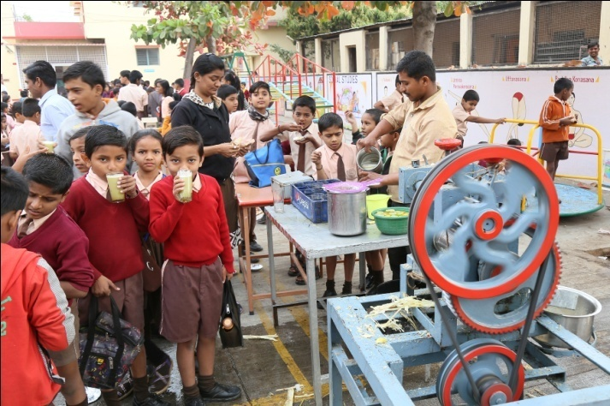The Management conducted Canteen day. Teachers arranged different food items and games in the school campus to help Holy Childhood, an International organization which takes care of the disadvantaged and needy children worldwide. We sincerely thank and appreciate the students, teachers and parents for their contribution for the noble cause.
* The Republic Day was celebrated in all its solemnity and grandeur at St. Paul’s School on 26th January. We saluted the National Flag and pledged ourselves to uphold the honour and integrity, diversity and uniqueness of our country.
* Picnics were organized for Pre-Primary Section to Paithan garden and Classes from Std. I to Std. IX to Devgad.

**Competitions**:

* Students from high school participated Maharashtra Talent Search Examination. We are proud to say that two students from our school got consolation prize in state level.
* Students participated in Scholarship Exam from Std. V to VIII and three students Pathan Tahura, Dagadkhair Vikrant and Sute Raunak were selected in merit list for the scholarship.
* Students from High School Section also participated Mathematic quiz competition held in Holycross High School Aurangabad.

**Meetings:**

* We have staff meetings where our director Rev. Dr. Valerian Fernandes, constantly reminds us of our commitment towards teaching profession and molding the students who are entrusted to us.
* There is a frequency of the interaction between the teachers and parents after every examination to discuss about their ward’s academic progress**.**

**Conclusion:** Before ending this report, I bow my head in reverence to the Almighty God for the blessings He has showered upon the institution.  I am glad to express my sincere gratitude to our director Rev. Dr. Valerian Fernandes for his genuine guidance and constant support. I also thank staff members and non-teaching staff, parents, benefactors and well wishers for their whole hearted co operation.

Let me sum up the report by entrusting our school into the divine hands of St. Paul, our Patron Saint and desire earnestly the diligence in learning, discipline in living, strength of mind in deciding and loyalty in profession.

 Thanking you and God bless you.

Headmistress